Lesson 35

Target: I can represent the multiplication of *n* times *a*/*b* as (*n* × *a)*/*b* using the associative property and visual models.

Concept Development (33 minutes)

Materials: (S) Personal white board

**Problem 1**: **Use the associative property to solve $\text{n}$ × $\frac{a}{b}$ in unit form.**

T: Write a multiplication number sentence to show four copies of 3 centimeters.

S: (Write 4 × 3 centimeters = 12 centimeters.)

T: (Write 4 × (3 centimeters).) I put parentheses around 3 centimeters to show that 3 is telling the number of centimeters in one group, but to solve, we moved the parentheses. Show me where you moved them to.

S: (Write (4 × 3) centimeters = 12 centimeters.)

T: Yes, you used the associative property by associating the 3 with the number of groups rather than the unit of centimeters.

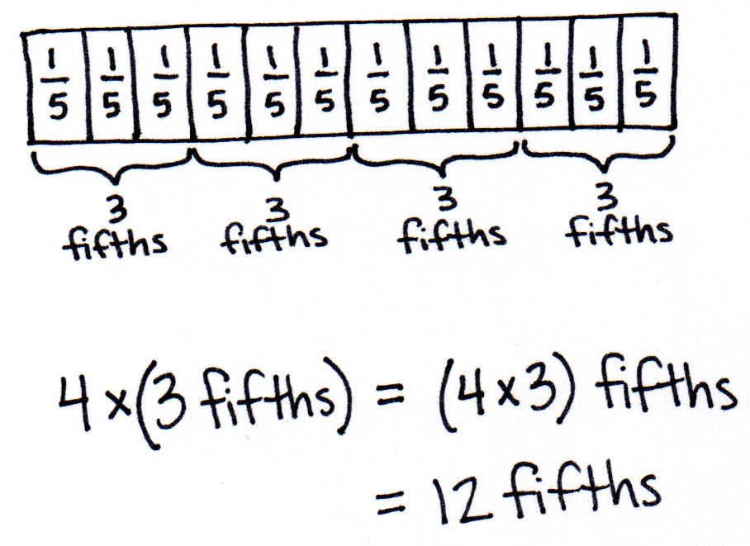T: Write a multiplication number sentence to show four copies of 3 fifths in unit form.

S: (Write 4 × 3 fifths = 12 fifths.)

T: (Write 4 × (3 fifths) = (4 × 3) fifths.) Is this true?

S: Yes, that’s the associative property.

T: Draw a tape diagram to show four copies of 3 fifths.

S: (Draw a tape diagram.)

Repeat with three copies of 5 sixths and four copies of 3 eighths, associating the factors and drawing a matching tape diagram.

Problem 2: Use the associative property to solve $\text{n}$ × $\frac{\text{a}}{\text{b}}$ numerically.

T: (Display 4 × $\frac{\text{3}}{\text{5}}$.) Say this expression.

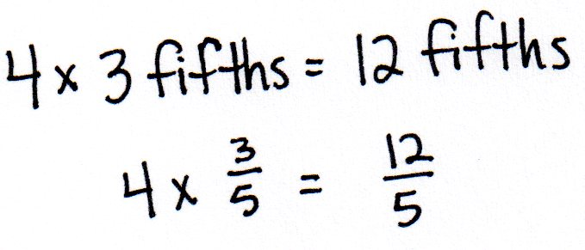S: Four times 3 fifths.

T: Write it in unit form.

S: (Write 4 × 3 fifths.) We just did this problem!

T: (Write 4 × 3 fifths = 12 fifths and 4 × $\frac{\text{3}}{\text{5}}=\frac{12}{5},$ as shown to the right.) Compare these number sentences. Are these true? Discuss with your partner.

S: Yes, the top was solved in unit form, and the bottom used numbers.

|  |  |
| --- | --- |
|  | NOTES ON  MULTIPLE MEANS  OF REPRESENTATION: |
| When using the associative property to solve 4 × $\frac{\text{3}}{\text{5}}$, some students may proficiently solve mentally, while others may need visual support to solve, including step-by-step guidance. For example, before asking for the value of (4 × 3) × $\frac{\text{1}}{\text{5}}$, it might be helpful to ask, “What is 12 × $\frac{\text{1}}{\text{5}}$?” | |

T: (Write 4 × (3 × $\frac{\text{1}}{\text{5}}$) = 4 × 3 fifths.) We can say   
4 × (3 × $\frac{\text{1}}{\text{5}}$) = 4 × 3 fifths. On your personal board, move the parentheses to associate the factors of 4 and 3.

S: (Write (4 × 3) × $\frac{\text{1}}{\text{5}}$.)

T: And the value is…?

S: $\frac{\text{12}}{\text{5}}.$

T: (Write 4 × (3 × $\frac{\text{1}}{\text{5}}$) = (4 × 3) × $\frac{\text{1}}{\text{5}}$ = $\frac{\text{12}}{\text{5}}$.)   
Is 4 groups of 3 fifths the same as 12 fifths?

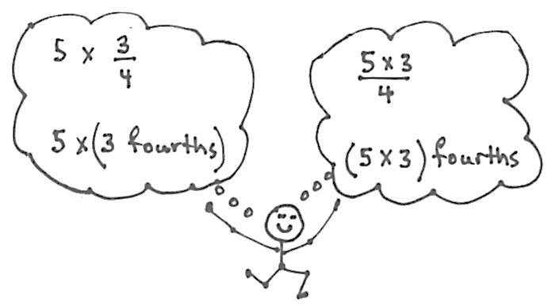S: Yes $.$

T: (Display 5 × $\frac{\text{3}}{\text{4}}$.) Say this expression.

S: Five times 3 fourths.

T: Keep the unit form in mind as you solve   
numerically. Record only as much as you need.

S: 5 × $\frac{\text{3}}{\text{4}}$ = $\frac{\text{15}}{\text{4}}.$ T: Yes, and as I thought of this as 5 times 3 fourths, I wrote down 5 × $\frac{\text{3}}{\text{4}}$ = $\frac{\text{5 × 3}}{\text{4}}$ = $\frac{\text{15}}{\text{4}}$. Why is my number sentence true?

S: When you associated the factors, fourths became the unit, and we write the unit fourths as the denominator.

T: Yes. I think of 5 × (3 fourths) as 5 × $\frac{\text{3}}{\text{4}}$ and (5 × 3) fourths as $\frac{\text{5 × 3}}{\text{4}}.$  
Both have the same value—12 fourths.

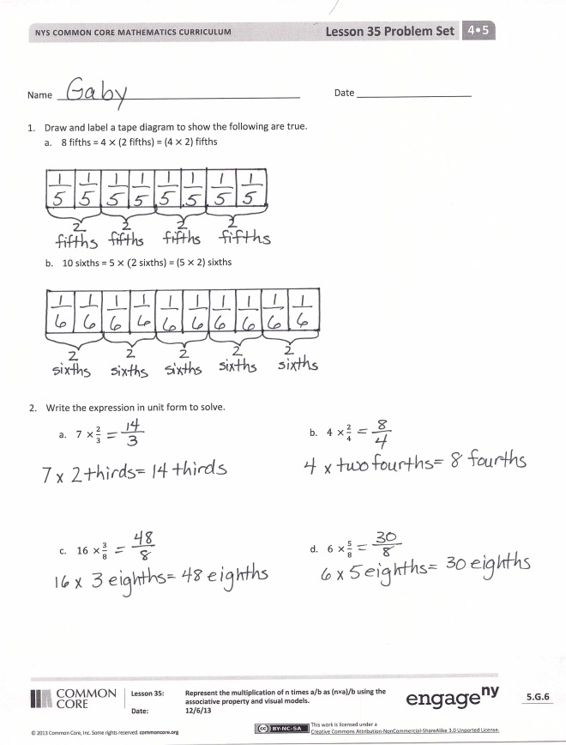

Repeat with 8 × $\frac{\text{2}}{\text{3}}$ and 12 × $\frac{\text{3}}{\text{10}}$.

Name Date

1. Draw and label a tape diagram to show the following are true.
2. 8 fifths = 4 $×$ (2 fifths) = (4 $×$ 2) fifths
3. 10 sixths = 5 $×$ $(2$ sixths) = (5 $×$ 2) sixths
4. Write the expression in unit form to solve.

$7×\frac{2}{3}$

$4×\frac{2}{4}$

$16×\frac{3}{8}$

$6×\frac{5}{8}$